Paper Template and Author Guidelines for the 3rd ICBC 2014 Your Paper Title Here
Petrus Kanisius Nusa¹ and Suharsono¹
¹Faculty of Business Administration and Communication Sciences,
Catholic University of Atmajaya, Jakarta,
Indonesia

Email: P. KanisiusN@atmajaya.co.id; Suharsono@atmajaya.co.id
Abstract:
Your paper should be produced in accordance with the guidance and formatting instructions contained and embedded within this electronic document. The abstract of your paper should be written in a single paragraph and should not exceed 300 words. Used TNR 10, italics, justified, single spaced. It should typically provide a brief overview of the research including its background, rationale, methodology, and conclusions.
Keywords: Up to 5 keywords should be provided in alphabetical order separated by commas. Formatting should be as described above.

Introduction
The main body of all papers should commence with an introduction section which should explain the background and purpose of the paper. Formatting is described in section 2 below.

Formatting of Main Headings
Main headings, including the introduction, should be formatted by selecting Heading 1 from the “styles and formatting” tool within Microsoft Word.

Formatting of Sub-Headings
Sub-headings can be added by selecting Heading 2 or Heading 3 as appropriate.

Formatting of Additional Levels of Sub-Heading
Additional levels of sub-heading can be added by selecting Heading 3. In the interests of clarity authors are not advised to use more than three levels of subheadings.

Submission of Papers
Papers should be between 4,000 and 7,500 words in length. You should create and submit your paper in Microsoft Word, using TNR 12, justified, single spaced.

Citation and Referencing Styles
Primary sources should be cited using footnotes, identified in the text by consecutive numbers in superscript, like this. The footnotes themselves should appear at the foot of each page in Times New Roman, 9 point. There is no need to also include primary legal sources in the ‘References’ section at the end of the paper which should be restricted to sources cited using the Harvard style.
The citation of secondary sources / references to other publications should use the Harvard referencing style. The full bibliographic description of the cited work should also appear in a ‘References’ section under the final main heading of the paper as described at the end of this document.

Figures and Tables
Figures and tables may be used to better illustrate the points made or to better present data. For figures, the figure caption should be numbered and positioned below the figure as follows.
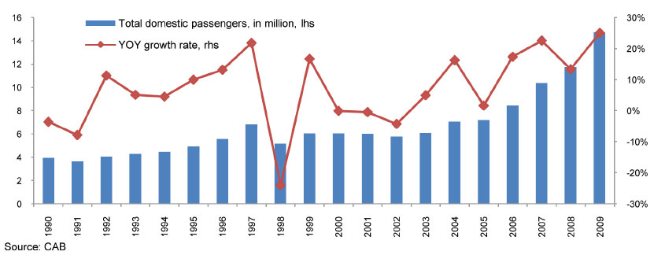

Figure 1. Domestic air travel, Philippines, millions, growth, 1990-2009
(Source: CAB, 2009)

For tables, the table caption should be numbered and positioned before the table as follows. One space should be added after the table.

Table 1. Domestic air travel, Philippines, millions, growth, 1990-2009

(Source: CAB, 2009)

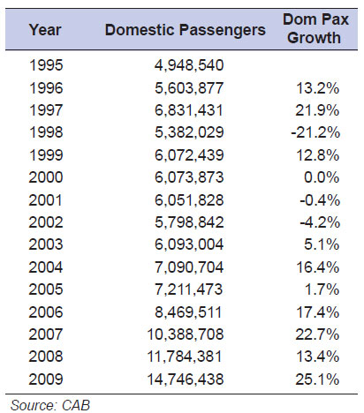

Acknowledgements
Any acknowledgements should be placed in a headed section immediately before the references section.

References
For citation and referencing systems used in this paper, author(s) should always refer to Harvard Referencing System.

Author1, Initials., Author2, Initials. and Author3, Initials. (Year), ‘Article Title’, Journal Title, Volume (issue no.), pp 34-45.
Author1, Initials., Author2, Initials. and Author3, Initials. (Year), Book title, Publisher, Place.
Author1, Initials., Author2, Initials. and Author3, Initials. (Year), ‘Article Title’, In: Editor(s), Book Title, Publisher, Place, pp 34-45.
Author1, Initials., Author2, Initials. and Author3, Initials. (Year), ‘Article Title’, In: Editor(s), Conference Proceeding, Publisher, Place, Dates of Conference, pp 34-45
Author1, Initials., Author2, Initials. and Author3, Initials. (Year), ‘Article Title’, Publication/Publisher, http://www.url_address.co/article1.htm , viewed: 31/12/2007.

This is an example of a footnote, which is in Times New Roman, 9point

